Step 1: Creating an account with the LMS or Logging in as a Returning User

Returning users
Access the Learning Management System (LMS) at the following link, and then skip to Step 2:
https://tyco.csod.com/client/tyco/default.aspx

Login to the LMS using your username and password.
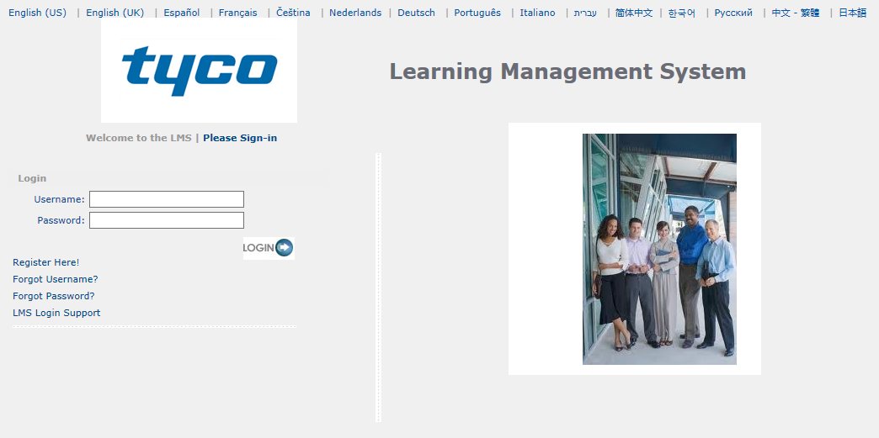
Figure 3: Main login screen

**To search for your desired course, please scroll down and follow STEP 2 – Payment.**

First time users
If this is the first time you are registering for a class online, access the registration portal at the following link:
https://tyco.csod.com/selfreg/register.aspx?c=marinette_distributors
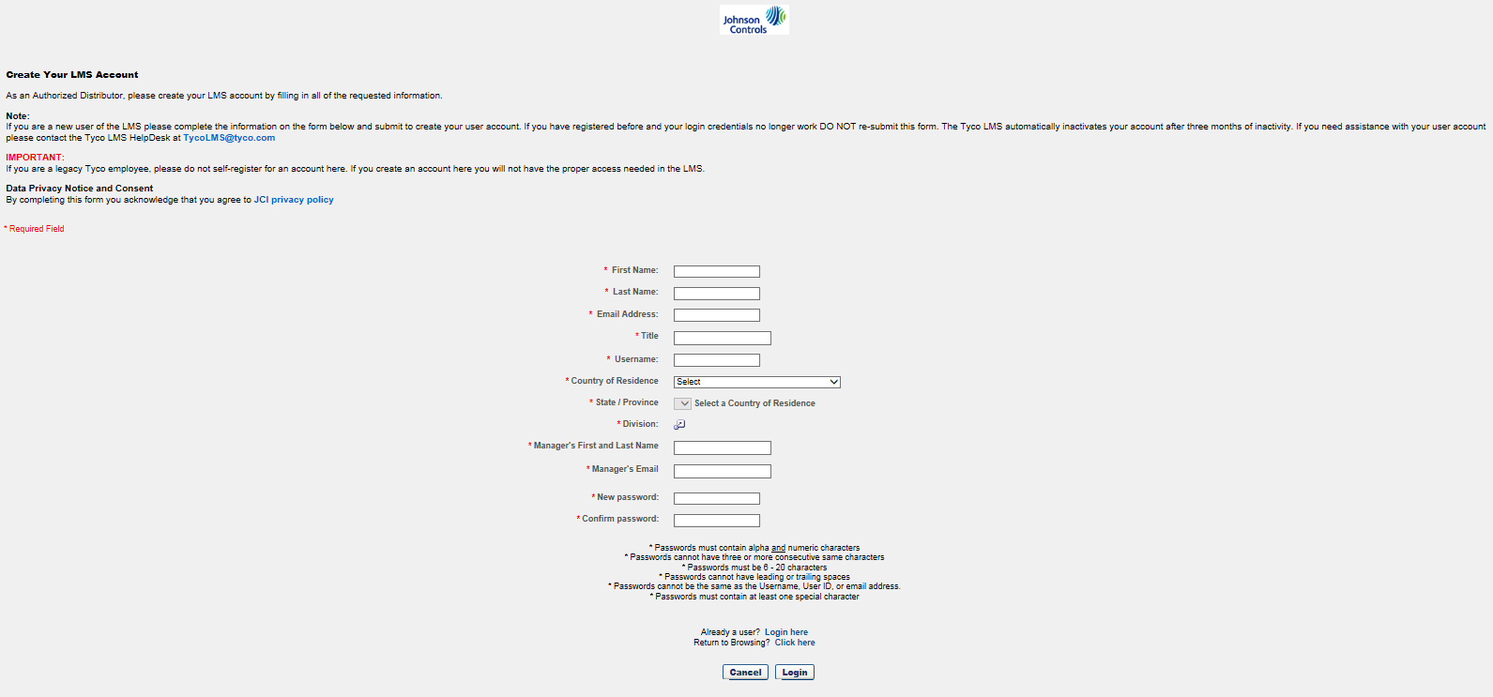

Figure 1: New user registration

- Create a new account by filling out the information requested in each box. Each student must be registered separately, and every student must have a unique email address associated with their account. Make sure to remember your username and password.
- To enter a Division, click on the icon (red arrow in Figure 1) to open a new pop-up as shown in Figure 2.
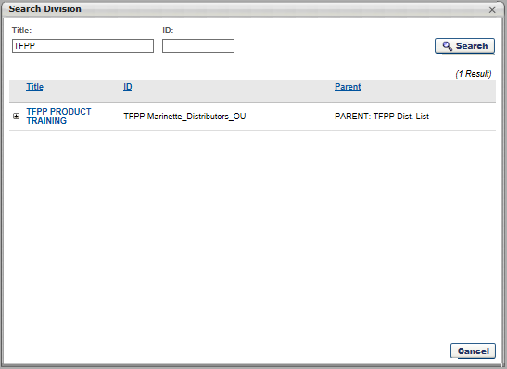

Figure 2: Division pop-up window

- Enter your company name in the “Title” field, and click on “Search”.
- Click on the appropriate company name in the search results.
Once you’ve completed your “New User” registration, you will be automatically logged in to the LMS.
- Make sure to remember your username and password.

Step 2:

Search for the desired course
- Click on the “Catalog” link in the Quick Links menu
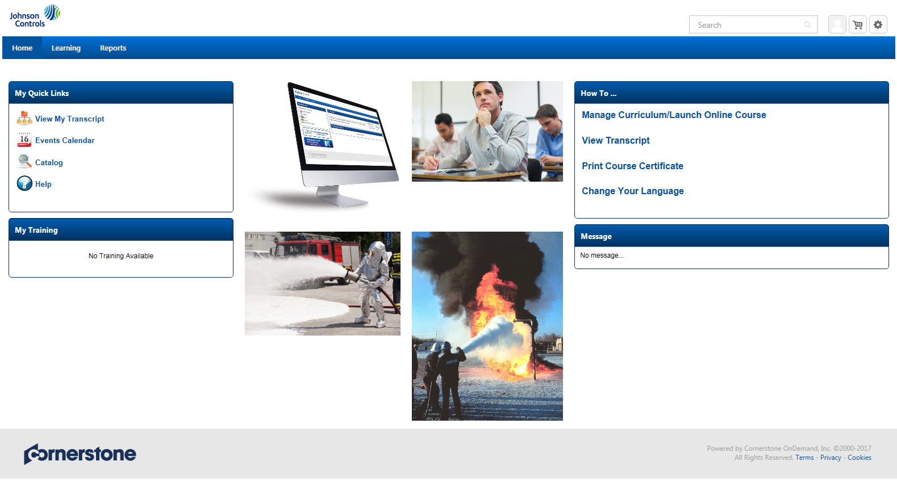

Figure 4: LMS Home screen

- Type the name of the class of product you are looking for
- Click on the desired class in the list of results
c
b
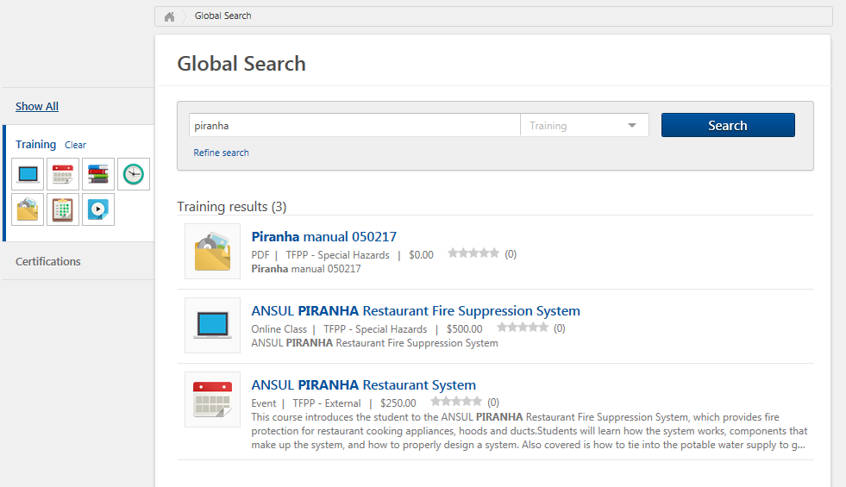

Figure 5: Catalog search

- Click the request button for the desire date/location of the class that you wish to attend
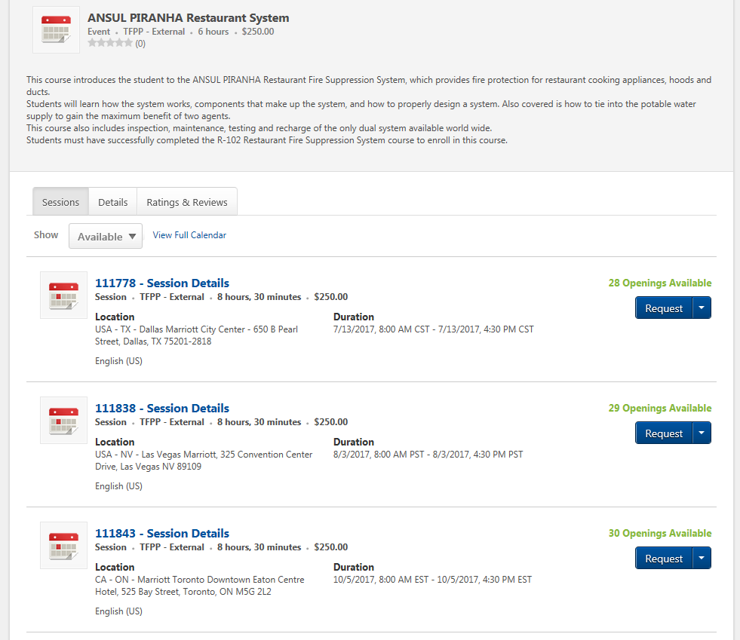

Figure 6: Class request window

Step 3:

Approval email
Once your eligibility for the class has been verified, you will receive an email that your request has been approved. YOU ARE STILL NOT REGISTERED FOR THE CLASS AT THIS POINT.
You must go back into the LMS to complete your registration for the desired class by following Step 4 – payment.

Step 4:

Register for desired course
Log into the LMS system (see step 1)
Click on “View My Transcript”

Figure 7: LMS Home screen

Find the class you wish to register for, and click on the “Register” button
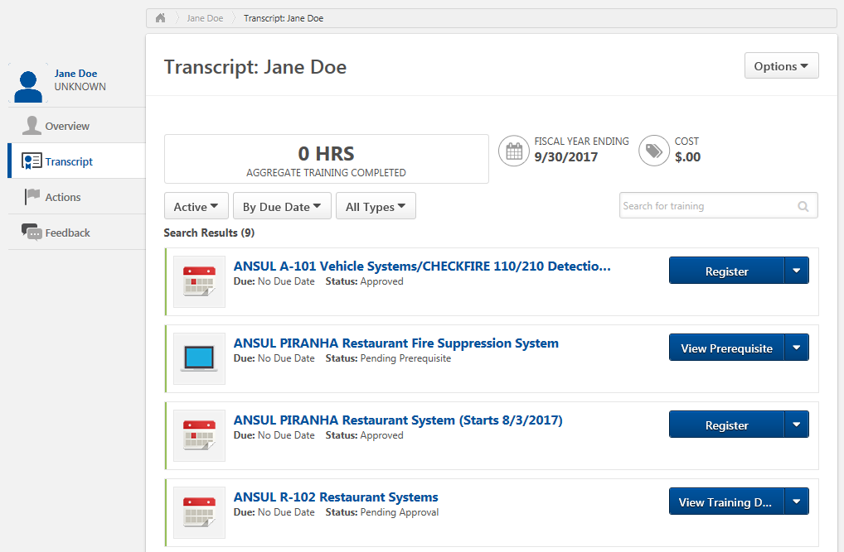

Figure 8: My Transcript window

Figure 9: Payment window
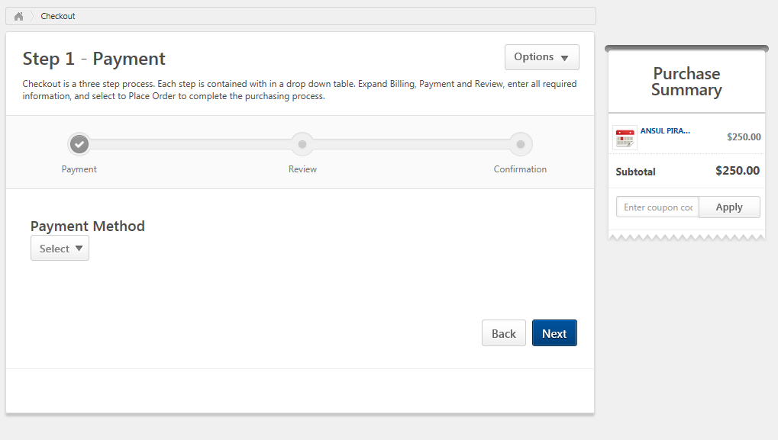

Payment
Select your payment method, and complete the required information.
**If you have a coupon code, you may enter it on the right side of screen under “Purchase Summary”**

**You will only be officially added to class roster once your payment has been received**

NOTE: You may NOT register for classes less than 7 days prior to the class start date.

